Stage 3 (Final tasks and fixes)

Overall issue: memory needs to be flushed. Since there is no “back” button, no reason to keep previous choices in memory. As it is, it is causing CPU freezes

Pairing right figure with right hair and shirt

Child – current condition (both default hair and default shirt wrong)

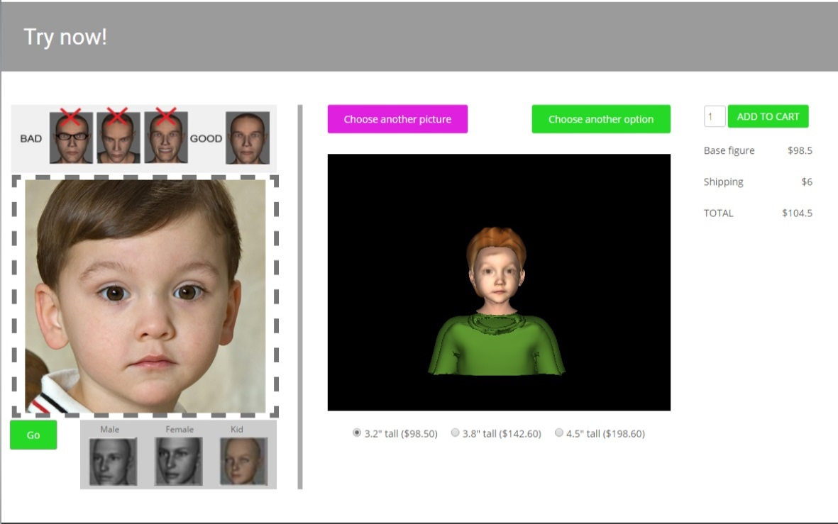

Desired condition Hair

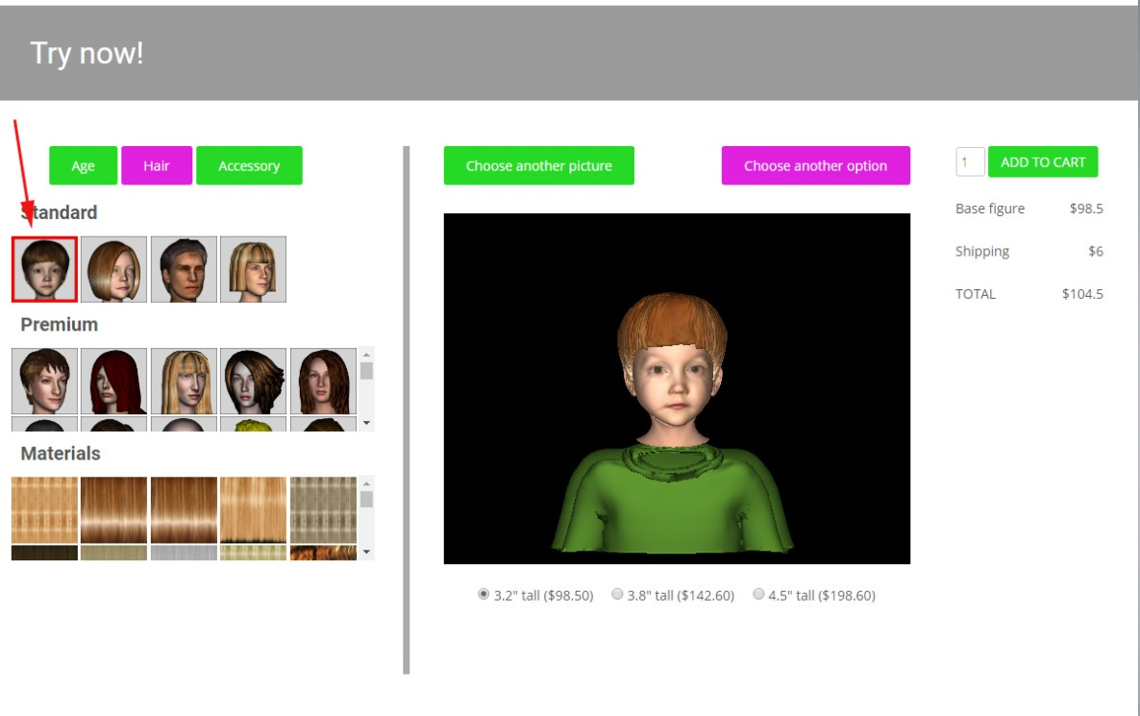

Desired condition Shirt

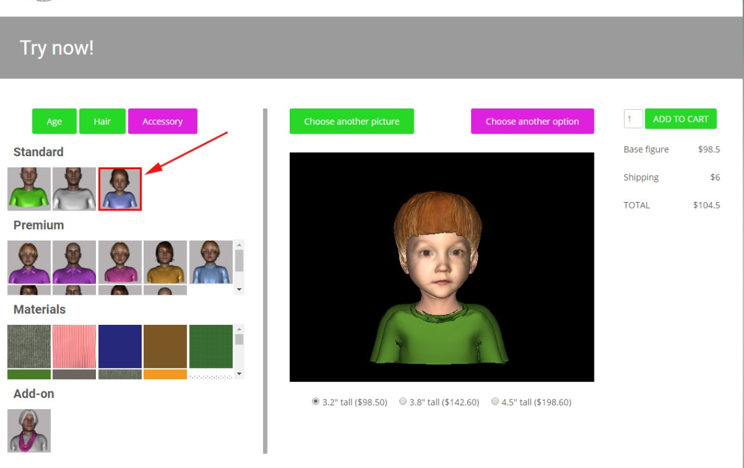

WOMAN

Current condition - Problem is that default picks up last choices in the previous session in all hair, shirt and morph

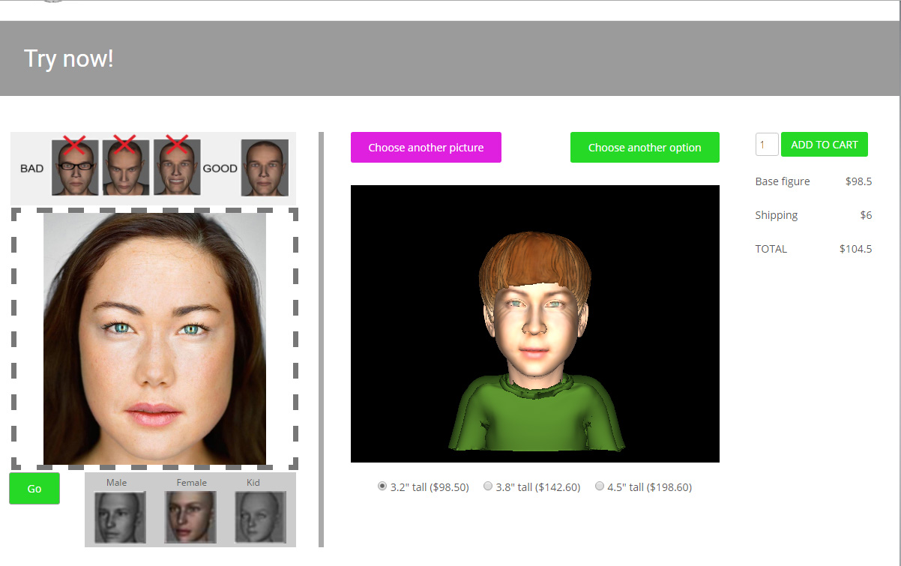

Desired condition Default Hair

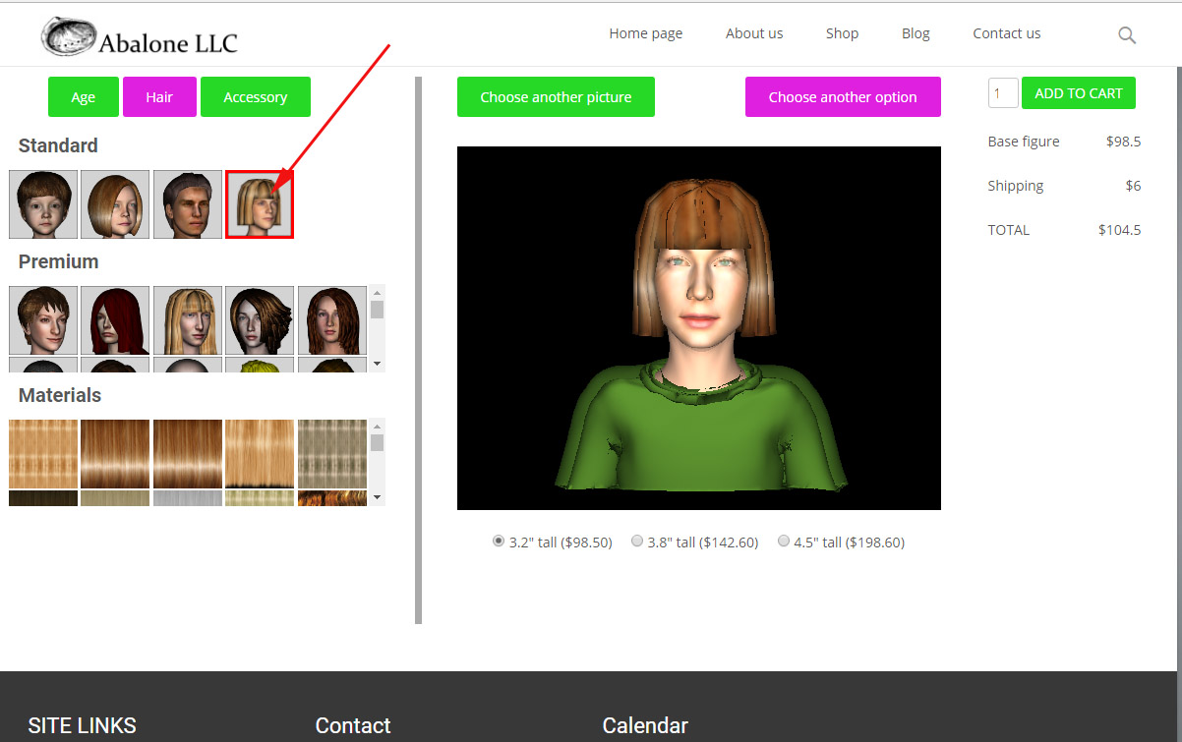

Desired Condition Default Shirt (OK)

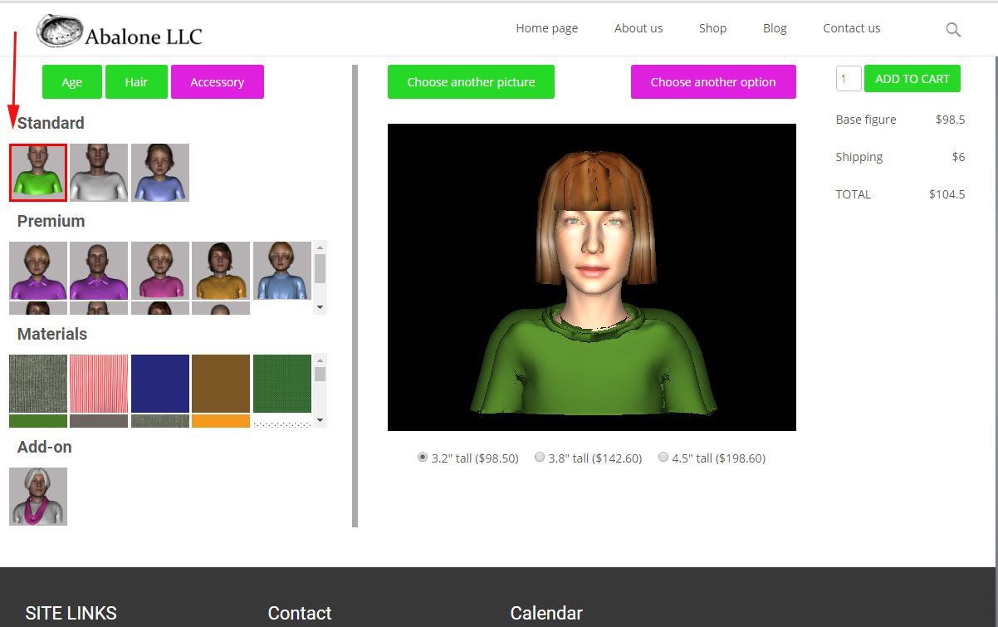

MALE

Current condition (same as with others, picks previous choices)

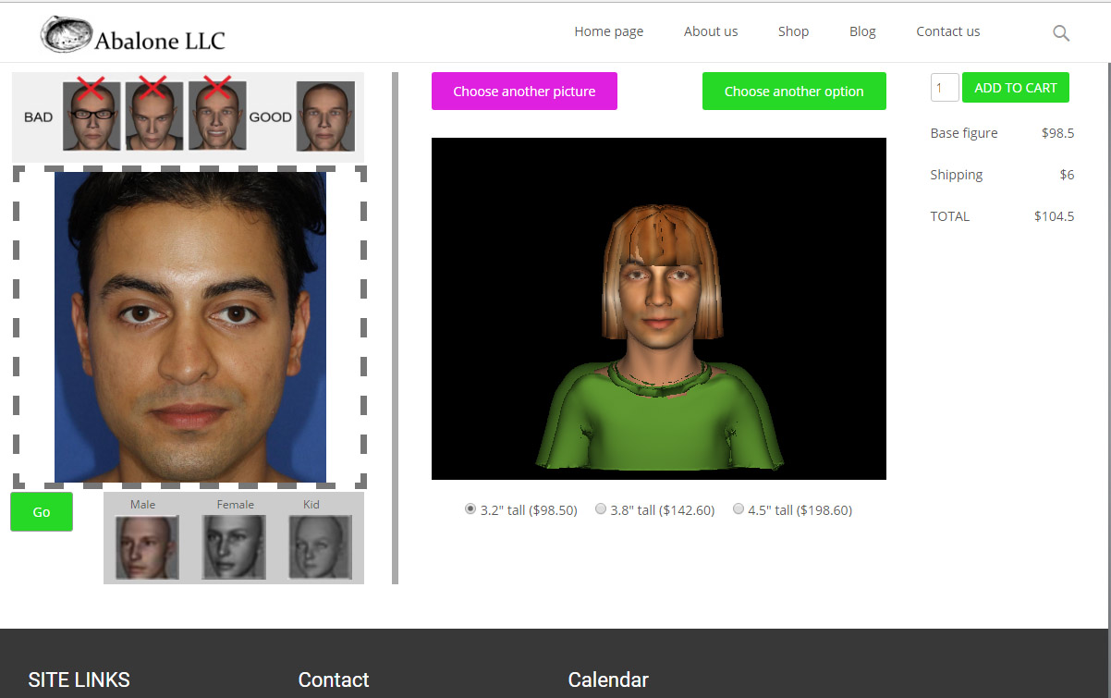

Desired condition Default Hair

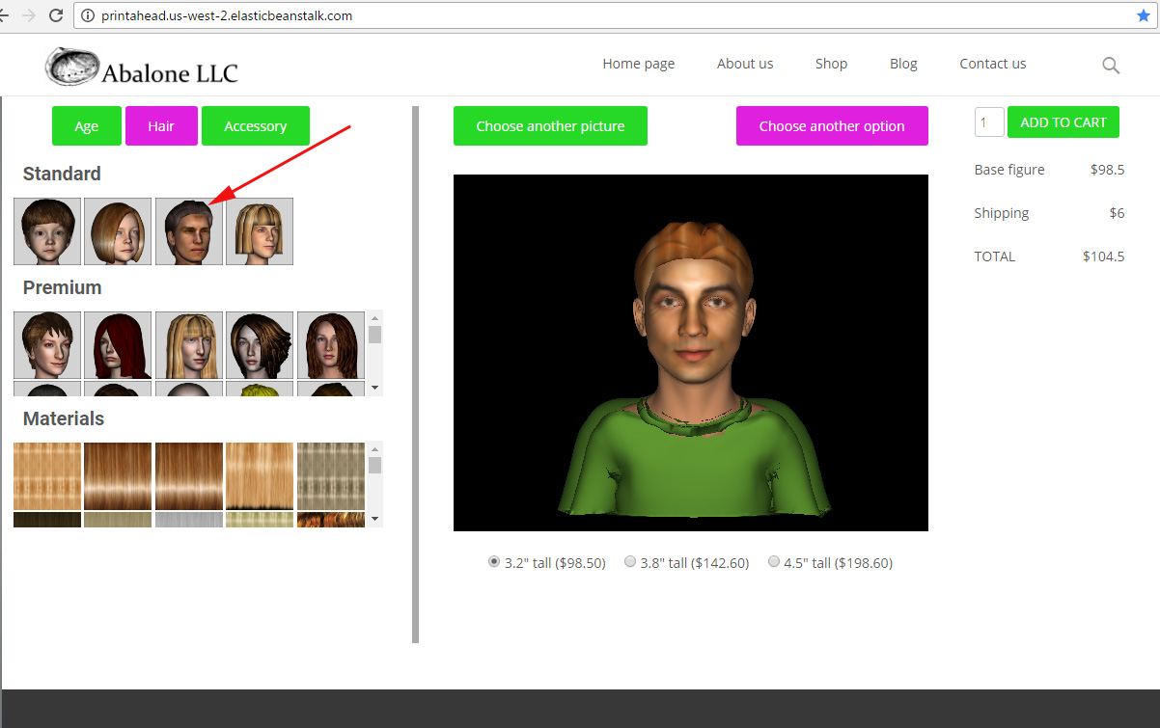

Desired condition Default Male Shirt

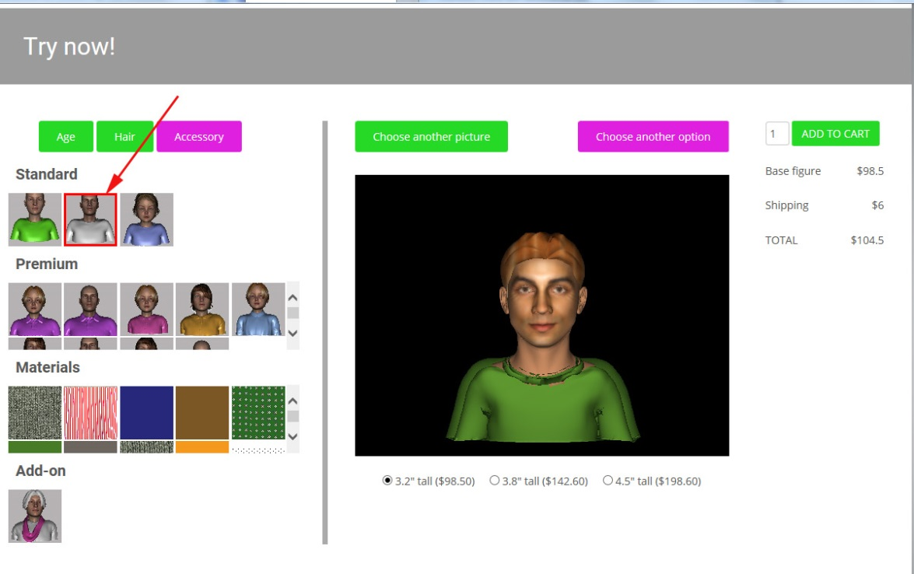

MORPHS

Need more study. Some work fine. My initial feeling is that issues are related to sliders not resetting to “0”.

NEW and CLEANUP TASKS ($200)

1. Please implement latest html conditions (blurb and task counter)

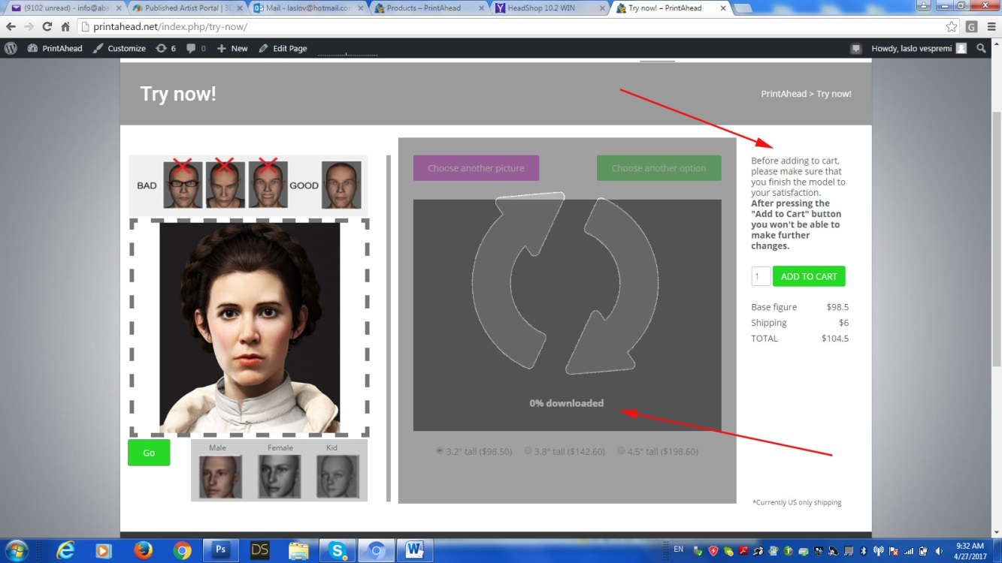

1. New task. When user clicks “Add to Cart”, the following needs to happen:
   1. App needs to size the figure precisely to the chosen output size (3.2, 3.8 or 4.5 inches)
   2. App needs to save the zip file with the generated order number (already in code?) to <https://www.dropbox.com/home/OUTPUT>
   3. Forward order number/price to printahead.net cart for checkout

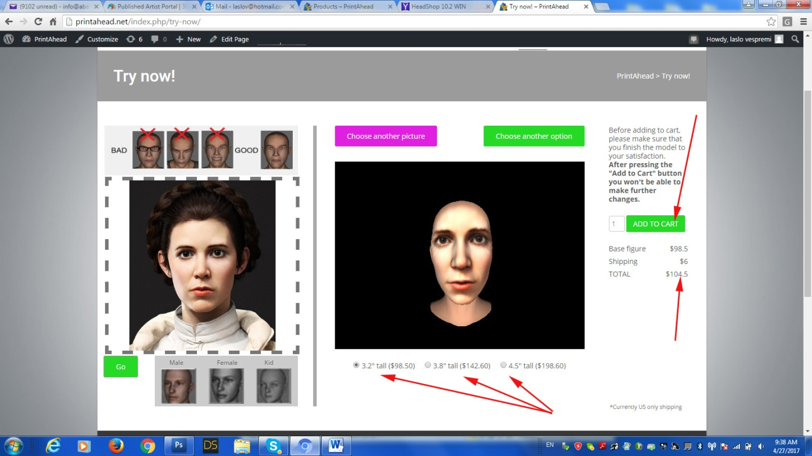

1. Cleanup tasks should be included in price. We will communicate as they come up during beta test